RHWU has been established since 1923 as the first government-run public hospital in Hubei province. In 1992, the hospital was ranked in the top first-class hospital in China by Ministry of Health of the People's Republic of China and was designated as one of the key window-hospital under construction by Hubei province government.

The hospital has two campuses. The main campus is located at Zhangzhidong Road, Wuchang district, occupying total land area of 13.3 hectares (200 Chinese Mu) with a construction area of 350,000 square meters. There are the advanced and full-functional medical buildings that reach international standards of care for out- and/ in-patients in RHWU. This full-service hospital has premier facilities including the operation rooms, Intense Care Unit (ICU), and Cardiac Catheterization Rooms (CCR), etc. which equipped with the high-grade air cleaning system, many top-class medical instruments, and an advanced stream-line management.
The hospital consists of 76 clinical departments and offers 3200 hospital-beds for inpatients. Many top-level medical instruments or apparatus used for diagnostic or therapeutic procedures, such as 3.0T and 1.5T Dual Gradient MRI, 64/128 CT, ECT/PET and IGRT LINAC radiotherapy systems were available here. The annual amounts of the patients treated in this hospital were 2.23 million for outpatients and 120,000 for inpatients.60,000 surgical operations were annually completed in RHWU. The medical service provided by this hospital was national-wide, some patients came from abroad.

The East campus(Wuhan Optics Valley General Hospita) is located at the center area of Wuhan East Lake High-Tech Development Zone, occupying total land area of 16.6 hectares (250 Chinese Mu) and potentially offering 2,300 hospital-beds for the patients. The new campus is under construction with a highlight on a high-tech, humanistic, gardened, and internationalized theme.
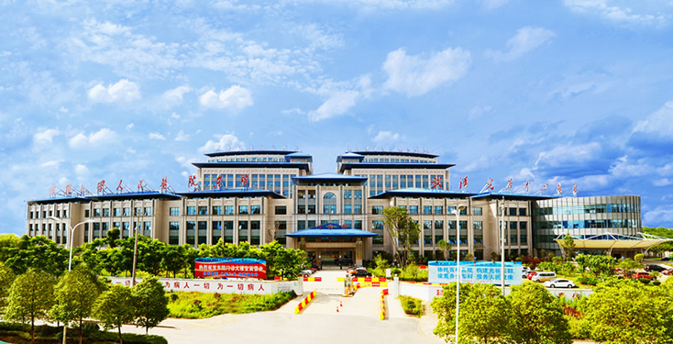
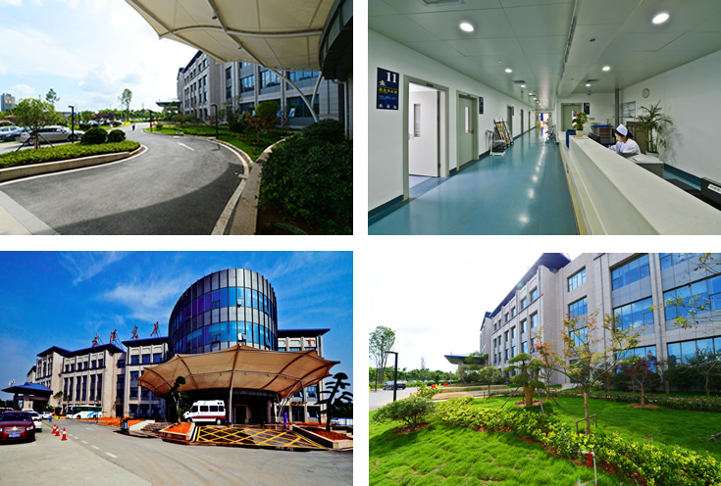
East Compus (Wuhan Optics Valley General Hospita),Open on Dec 15, 2013
There are 5100 employees in RHWU, including 580 full-professors (or equivalent), associate professors (or equivalent), and other medical care personnel. We are honored to have a lot of national-grade outstanding specialists, PhD/MD candidate mentors, and the specialists who enjoy the special government allowance granted by the State Council. We are also honored to invite Nobel Prize holder and more than 30 members of Chinese Academy of Engineering (CAE) or Chinese Academy of Science (CAS) as our guest professor or part-time professor.

The post-doctoral research station in clinical medicine was authorized to be set up in RHWU by Ministry of Personnel of the People's Republic of China. One first-level discipline of clinical medicine was authorized to confer doctoral degrees authorized by the academic degree committee of the State Council, seven disciplines of clinical medicine, biomedical engineering, combine traditional Chinese and western medicine, stomatology, pharmacy, traditional Chinese medicine and nursing science to confer master degrees. 2,600 undergraduate students were enrolled annually in Wuhan university school of medicine for the registration of 5-, 7-, and 8-years bachelor degree programs. 800 candidates of doctor or master degree as well as foreign students, 600 junior physicians completed their apprenticeship program in RHWU.
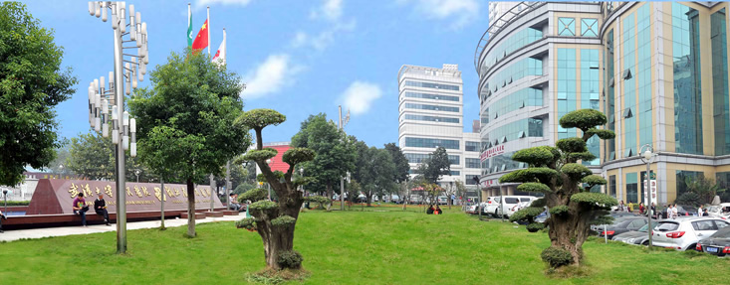
A complete set of clinical medical disciplines is available in RHWU to cover every field of modern medicine, including the department of cardiology, gastroenterology, nephrology, respiratory medicine, hematology, endocrinology, allergy, cardiovascular surgery, thoracic surgery, urology, orthopedics, neurosurgery, general surgery and plastic surgery, gynecology, obstetrics, reproductive medicine, pediatrics, oncology, neurology, psychiatry, ophthalmic, otorhinolaryngology, dermatovenerology, stomatology, rehabilitation, and traditional Chinese medicine. Cardiology department is one of the national key disciplines, the departments of cardiology, thoracic surgery, otorhinolaryngology, psychiatry, nephrology, neurology, ophthalmic, and laboratory medicine are the national clinical key specialty. The Departments of internal medicine and surgery are the provincial key disciplines in Hubei. The specialties on cardiovascular diseases (involving in departments of cardiology and cardiovascular surgery), neurological diseases (involving in departments of neurology and neuro-surgery) and ophthalmic diseases are the key construction specialties of national or provincial level, which authorized by Wuhan municipal government for the development of Health Care Center in central China.
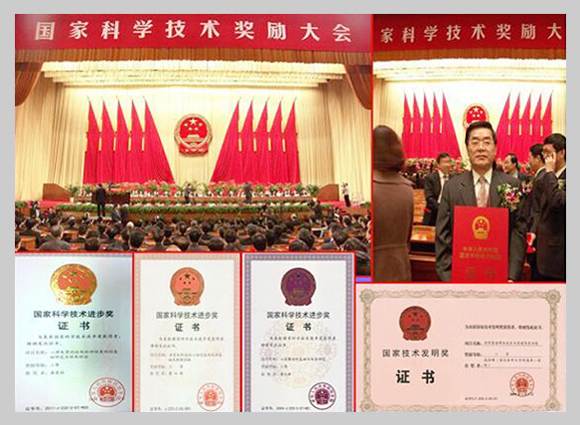
One national invention accessit of technology
Three national progress accessits of technology
One of the national progress third-prize on science and technology
At RHWU, there are 5 key laboratories, 3 research bases, 8 medical centers, and 10 research institutes, namely the national key laboratory on clinical virology, key laboratory on cardiac arrhythmias authorized by the Ministry of Health, and the provincial key laboratories on cardiovasology, gastroenterology in Hubei, national grade-III laboratory on traditional Chinese medicine, cardiac electrophysiology, and digestive pathphysiology; State base for drug clinical trial, the training bases on cardiovasology intervention therapy and peritoneal dialysis authorized by the Ministry of Health; The provincial medical centers on cardiovasology and eye diseases, the provincial quality control centers on cardiovasology intervention therapy, nephrology therapy, endoscopy therapy for digestive diseases, ultrasound therapy, and psychosis therapy, The model animal research center offers a full-functional facility to study human diseases in molecular and cellular level; The provincial institutes of neurology, psychiatry, and pediatrics authorized by Hubei province government, the institutes of cardiovascular diseases, gastroenterology, hepatology, urology, eye diseases, and otorhinolaryngology-head-neck surgery authorized by Wuhan university.
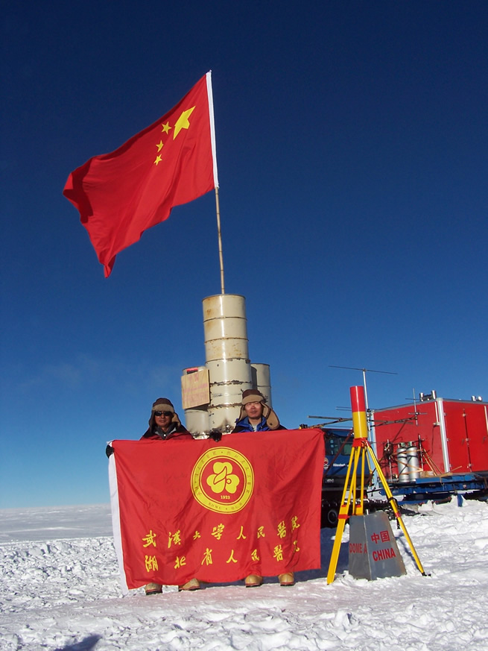
Prof. Tong Hexiang took part in the team of Chinese scientific investigation for antarctic.
During the past 10 years, RHWU has been honored more than 200 awards on scientific achievements, including one national invention accessit of technology, three national progress accessits of the science and technology, and one of the national progress third-prize on science and technology. The publication of scientific articles in number is ranked at the 11-th position among nationwide medical organizations. The number of the articles published in the world's most respected scientific journals was ranked at the top position among nationwide medical organizations in 2012. The publication of scientific articles in number was ranked at the 11th position among national-wide medical organizations in 2013. The comprehensive influence was ranked at the 23rd position among national-wide medical organization in 2014.

