Introduction of Shijiazhuang, Hebei Province
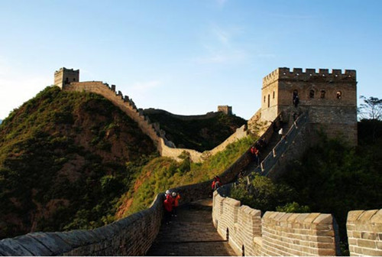
Introduction of Hebei Province
Hebei Province is called ‘Ji’ for short, meaning ‘Hope’. Hebei is a coastal province in the eastern part of China opening to the outside world. It covers a total area of 187,700 square kilometers and is the only province in China that boasts highlands, mountainous regions, rolling hills, plains, lakes, an the seaside. It has rich mineral, animal, plant and marine resources and sources of energy such as terrestrial neat, wind power, solar energy an bio-energy. The continental, monsoon climate of the subtropical zone gives the province pleasant weather and four distinct seasons. Hebei Province now has a population of 67,000,000, with 54 nationalities. Its provincial capital is Shijiazhuang.
In the long course of history, a large number of historical sites and ancient cultural remains have been let in Hebei. Hebei has three places that have been listed as world cultural heritage sites, and the number of its major cultural relics under protection at the provincial level ranks first in the country.
Today, Hebei Province is blessed with unique geographical features surrounding - Beijing and Tianjin, running along the coastline of the Bohai Sea and linking China’s northeast, northwest and north. It has become one of the regions with the greatest potential for economic development
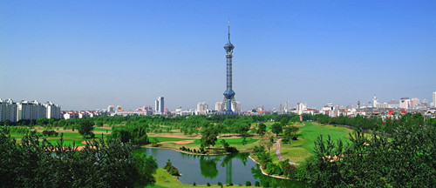
Introduction of Shijiazhuang
Shijiazhuang is the capital and largest city of Hebei Province in North China. Administratively a prefecture-level city, it is about 280 kilometers(170 mi) southwest of Beijing.
Shijiazhuang has a total population of 10,163,788, with 2,604,930 in the urban area. Shijiazhuang is a newly industrialized city. It experienced dramatic growth after the founding of the People’s Republic of China in 1949. The population of the metropolitan area has more than quadrupled in only 30 years. It is a central hub of transportation routes.
As the provincial capital, Shijiazhuang is also the political, economic, cultural and the transportation center of the province. Shijiazhuang is becoming more and more beautiful with recent urban development A jade-like moat embraces the city gently, bordered by 20 charming parks. This beautiful city is filled with culture and development, attracting visitors with new features daily.
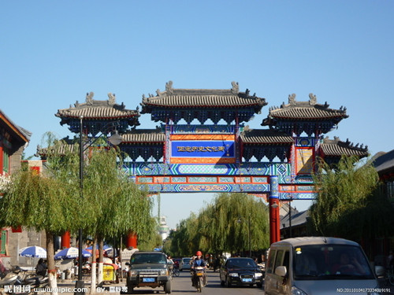
Zhengding County
The city of Shijiazhuang is filled with grand historical relics as well as many beautiful natural and magical scenes. The national historic and cultural county Zhengding, 15 KM north of Shijiazhuang, is famous for its “ nine pavilions, four pagodas, eight temples, and twenty-four golden memorial archways”. Zhengding has been an important religious center for more than 1,000 years, from- at least- the times of the Sui Dynasty to the Qing Dynasty. It is the founding place of several major schools of Zen Buddhism.
In this two-thousand-year-old county, one must visit majestic Longxing Temple, which houses the largest copper figure of thousand-armed Avalokitesvara Bodhisattva in China. Furthermore, four famous pagodas, each with its own architectural style, are still standing.
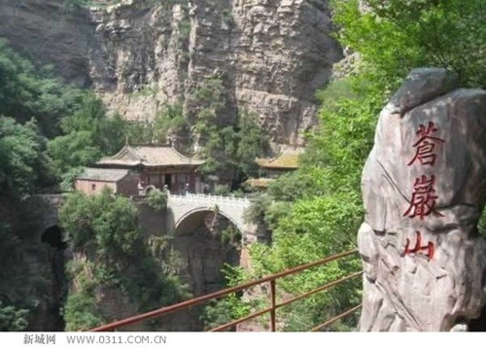
Mount Cangyan
Mount Cangyan( Green Cliff Mountain) is a scenic are, famous for its combination of natural mountain scenery with historical man-made structures. Mount Cangyan forms the eastern tip of the Taihang Mountain Range. Its tallest peak has an altitude of 1,000 meters. The scenic area covers 63 square kilometers.
The most famous building complex on Mount Cangyan is the Fuqing Temple. It was first built during the Sui Dynasty and is said to have been the place where Princess Nan Yang, the daughter of the Sui Emperor Yang, practiced Buddhism. The various structures of the Fuqing Temple(the Tablets House, the Hall of the Heavenly Kings, the Hall of the Giant Buddha, the Bridge-Tower Hall, the Buddhist Canon Depository) are well integrated into the mountain topography. The central landmark of the complex is the Bridge-Tower Hall. It boasts one of China’s three intriguing hanging temples. As the name suggests, it is supported by a stone arch bridge spanning a narrow gorge. The bridge has a span of 15 meters and stands 52 meters above ground, and it is constructed from 365 stone blocks. Under the bridge a stone staircase with more than 360 steps leads up to the summit.
Cangyan Shan was used as setting for filming some scenes in the movie “Crouching Tiger, Hidden Dragon” directed by the famous director Ang Lee.
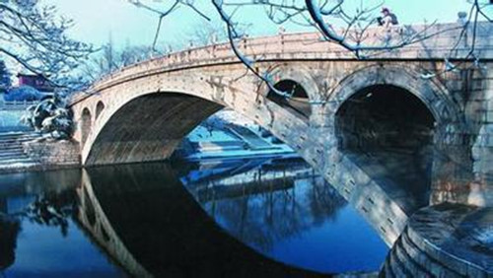
The Anji Bridge
In the southern part of Shijiazhuang stands the Anji Bridge, the oldest stone bridge in China. It is also features the world’s oldest open-spandrel stone segmental arch bridge. Credited to the design of a craftsman named Li Chun, the bridge was constructed in the years 595-605 during the Sui Dynasty(581-618). The bridge is also commonly known as the Zhaozhou Bridge, after Zhao County, which was formerly known as Zhaozhou.
In the next 1400 years, the bridge survived at least eight wars, ten major floods and numerous earthquakes. Yet, the support structure remains intact and the bridge is still in use. Only the ornamental railings have been replaced every few hundred years.
The Anji bridge influenced the design of later Chinese bridge structures. The intriguing design of the Anji bridge has given rise to many legends. According to one legend, the bridge was built by a master architect named Lu Ban in a single night. In another story, the bridge was put to saved it by wading into wading and supporting the structure.
Thanks to its elegant structure, it was compared to “a new moon rising above the clouds ” and “a long rainbow hanging on a mountain waterfall”. When Professor Liang Sicheng of Tsinghua University rediscovered the bridge on a field exploration of ancient architecture in Hebei province, made detailed measurements, and published a report and drawing, it became world famous.
Anji Bridge was dedicated as an International Historic Civil Engineering Landmark b the American Society of Civil Engineers in 1991. In 1996, the Chinese authorities nominate it for inclusion in the World Heritage List as having “a very important place in the world bridge building history”.

