BHI data

Our campus covers an area of 200 thousand square meters, and the overall building area is 100 thousand square meters.
Three subjects are offered, namely "Hospitality Management","Hotel Business English" and Hotel Financial Management.
There are currently 3054 students, 268 faculty and staff.
Four thousand in-school students can be accommodated at BHI’s full capacity.
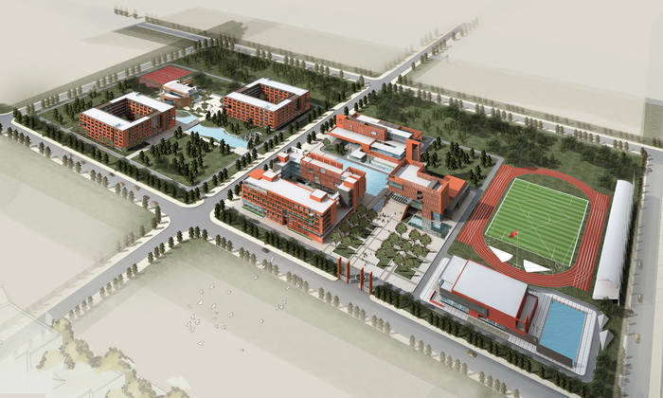
Bird's eye view
The campus of BHI includes two parts: the teaching and learning area and residential area. In the teaching area we have a library, gymnasium, stadium, language lab, wine-tasting lab, information systems lab, Chinese and Western style Demo kitchens and a 4-star teaching hotel. In the residential area we have a cafeteria, an indoor tennis court and student hotel. Every 4 students share a room, in which they enjoy facilities including a bathroom, air conditioning, 24-hour hot water and super fast broadband service at 100 Megabit.
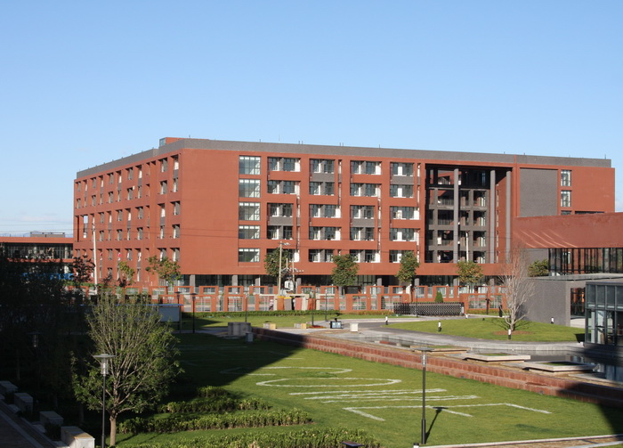
Student Hotel
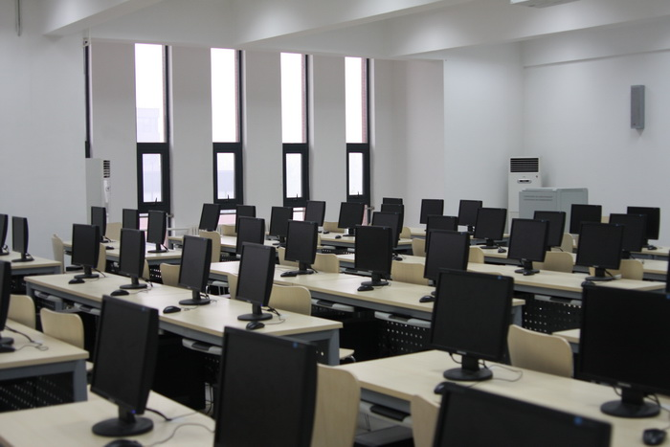
Computer Lab
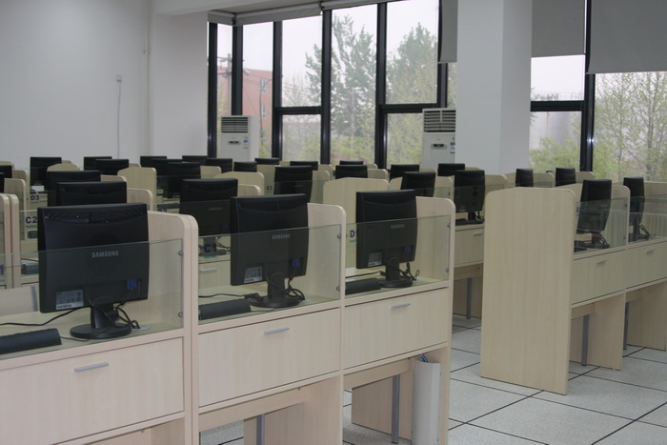
Language Laboratory
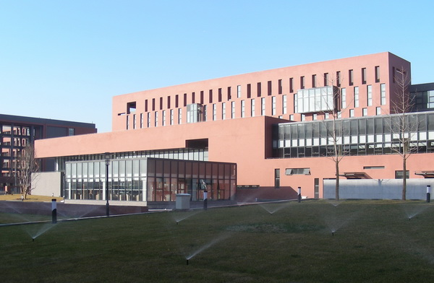
The Teaching Hotel
More photos

